Program Cover Sheet

|  |
| --- |
| Name: Madison Kell |
| Assignment: 7 |
| List any parts of the assignment that do not work/were not completed:  Directly manipulating text boxes- I had the same error last assignment but I did not figure out how to refresh the  List box once the item was added to the dictionary |

|  |
| --- |
| Instructor’s Comments: |
| Grade: |

Program Submission Requirements: (1) all files, zipped and uploaded to Canvas and (2) a completed cover sheet, program execution screenshots and source code printed, **stapled** and turned in during class. Failure to follow the submission requirements will result in points lost on that particular assignment.

'------------------------------------------------------------

'- File Name : frmChezSouSad.frm -

'- Part of Project: Assign4 -

'------------------------------------------------------------

'- Written By: Madison Kell -

'- Written On: February 11, 2022 -

'------------------------------------------------------------

'- File Purpose: -

'- This file contains the main application form where the -

'- user will decide their menu for the their meal. The user

' can add specific raw ingredients to be added to their

' selected prepped item which then can be added to the dish.

'------------------------------------------------------------

'- Program Purpose: -

'- -

'- This program uses dictionaries to create an active menu

' selection for users. These dictionaries are nested and

' communicate with eachother to effectively while adding,

' removing, adn sorting the list items and selected items.

' This program also error handles bad input.

'------------------------------------------------------------

'- Global Variable Dictionary (alphabetically): -

'- gdicDishes - global dictionary to hold the dish dictionary

' that holds a string, as well as another

' dictionary(prepped) that also holds a dictionary(raw)

'– gdicPreppedItems - global dictionary to hold the prepped

' items and also another dictionary

' to hold the raw dictionary

'- gdicRawItems - global dictionary to hold the raw items

'- PATTERN - a regex pattern to validate user input from the

' txt boxes, does not allow special characters to be added

'- STRDUPLICATEERROR - a simple string that holds an error message

'- STRREGEXERROR - a simple string that holds an error message

'------------------------------------------------------------

Imports System.Text.RegularExpressions

Public Class frmChezSouSad

'global dictionary to hold the raw items

Public gdicRawItems As New SortedDictionary(Of String, String)

'global dictionary to hold the prepped items and also another dictionary to hold the raw dictionary

Public gdicPreppedItems As New SortedDictionary(Of String, SortedDictionary(Of String, String))

'global dictionary to hold the dish dictionary that holds a string, as well as another dictionary(prepped) that also holds a dictionary(raw)

Public gdicDishes As New SortedDictionary(Of String, SortedDictionary(Of String, SortedDictionary(Of String, String)))

'a regex pattern to validate user input from the txt boxes, does not allow special characters to be added

Const PATTERN As String = "^[a-zA-Z]+$"

'a simple string that holds an error message

Const STRDUPLICATEERROR As String = "Selection already added."

'a simple string that holds an error message

Const STRREGEXERROR As String = "No special characters allowed. Please enter a valid food item."

Private Sub frmChezSouSad_Load(sender As Object, e As EventArgs) Handles MyBase.Load

'------------------------------------------------------------

'- Subprogram Name: frmChezSouSad_Load -

'------------------------------------------------------------

'- Written By: Madison Kell -

'- Written On: February 11, 2022 -

'------------------------------------------------------------

'- Subprogram Purpose: -

'- -

'- This subroutine is called whenever form loads. The form

'– will have some preloaded data for user convienience, and

' and that information is stored and created here.

'------------------------------------------------------------

'- Parameter Dictionary (in parameter order): -

'- sender – Identifies which particular control raised the –

'- click event -

'- e – Holds the EventArgs object sent to the routine -

'------------------------------------------------------------

'- Local Variable Dictionary (alphabetically): -

'- dicChickenSalad- Creating a dictionary to hold some selected

' raw chicken salad ingredients

'- dicChickenSaladPlatter - creating a dictionary to hold the

' prepped dictionary anda string

'- dicHamburger-Creating a dictionary to hold some selected

' raw hamburger ingredients

'- dicHamburgerPlatter- creating a dictionary to hold the

' prepped dictionary anda string

'- dicSoda- Creating a dictionary to hold some selected raw

' soda ingredients

'------------------------------------------------------------

'adding hardcoded random raw ingredients to the list like you had mentioned in the lecture

gdicRawItems.Add("beef patty", "beef patty")

gdicRawItems.Add("bun", "bun")

gdicRawItems.Add("chicken", "chicken")

gdicRawItems.Add("glass", "glass")

gdicRawItems.Add("lettuce", "lettuce")

gdicRawItems.Add("basket", "basket")

gdicRawItems.Add("mayo", "mayo")

gdicRawItems.Add("sugar", "sugar")

gdicRawItems.Add("water", "water")

'Creating a dictionary to hold some hard coded values

Dim dicHamburger As New SortedDictionary(Of String, String)

'adding some raw ingredients to this prepped ingredient

dicHamburger.Add("bun", gdicRawItems("bun"))

dicHamburger.Add("beef patty", gdicRawItems("beef patty"))

dicHamburger.Add("basket", gdicRawItems("basket"))

'adding the prepped item to the prepped item dictionary

gdicPreppedItems.Add("hamburger", dicHamburger)

'Creating a dictionary to hold some hard coded values

Dim dicSoda As New SortedDictionary(Of String, String)

'adding some raw ingredients to this prepped ingredient

dicSoda.Add("sugar", gdicRawItems("sugar"))

dicSoda.Add("water", gdicRawItems("water"))

dicSoda.Add("glass", gdicRawItems("glass"))

'adding the prepped item to the prepped item dictionary

gdicPreppedItems.Add("soda", dicSoda)

'Creating a dictionary to hold some hard coded values

Dim dicChickenSalad As New SortedDictionary(Of String, String)

'adding some raw ingredients to this prepped ingredient

dicChickenSalad.Add("lettuce", gdicRawItems("lettuce"))

dicChickenSalad.Add("chicken", gdicRawItems("chicken"))

dicChickenSalad.Add("mayo", gdicRawItems("mayo"))

'adding the prepped item to the prepped item dictionary

gdicPreppedItems.Add("chicken salad", dicChickenSalad)

'Creating a specific dish dictionary to hold some hard coded values

Dim dicChickenSaladPlatter As New SortedDictionary(Of String, SortedDictionary(Of String, String))

'adding the prepped item to the dish

dicChickenSaladPlatter.Add("chicken salad", gdicPreppedItems("chicken salad"))

'adding the dish to the dish dictionary

gdicDishes.Add("chicken salad platter", dicChickenSaladPlatter)

'Creating a specicic dish dictionary to hold some hard coded values

Dim dicHamburgerPlatter As New SortedDictionary(Of String, SortedDictionary(Of String, String))

'adding the prepped items to the dish

dicHamburgerPlatter.Add("hamburger", gdicPreppedItems("hamburger"))

dicHamburgerPlatter.Add("soda", gdicPreppedItems("soda"))

'adding the dish to the dish dictionary

gdicDishes.Add("hamburger platter", dicHamburgerPlatter)

'loop through each item added to the dictionary

For Each item In gdicRawItems.Values

'show them in the list box

lstRaw.Items.Add(item.ToLower)

Next

'loop through each item added to the dictionary

For Each item In gdicPreppedItems.Keys

'show them in the list box

lstPreppedItems.Items.Add(item.ToLower)

Next

'loop through each item added to the dictionary

For Each item In gdicDishes.Keys

'show them in the list box

lstDishes.Items.Add(item.ToLower)

Next

End Sub

Private Sub btnAddPreppedItem_Click(sender As Object, e As EventArgs) Handles btnAddPreppedItem.Click

'------------------------------------------------------------

'- Subprogram Name: btnQuit_Click -

'------------------------------------------------------------

'- Written By: Madison Kell -

'- Written On: February 11, 2022 -

'------------------------------------------------------------

'- Subprogram Purpose: -

'- -

'- This subroutine is called whenever the user clicks the -

'- add prepped item button. This function will check to see

'– if the user input is valid, and add the new information

'- to its own dictionary. Proper error handling is also in

' place.

'------------------------------------------------------------

'- Parameter Dictionary (in parameter order): -

'- sender – Identifies which particular control raised the –

'- click event -

'- e – Holds the EventArgs object sent to the routine -

'------------------------------------------------------------

'- Local Variable Dictionary (alphabetically): -

'- dicNewPrepped- creating a new dictionary to hold

' the selected prepped items

'- strText- a variable to hold the value of the text box

' so I dont have to type it so much

'------------------------------------------------------------

'creating a new dictionary to hold the selected information

Dim dicNewPrepped As New SortedDictionary(Of String, String)

'set a variable to hold the text so I dont have to type it so much

Dim strText As String = txtAddPreppedItem.Text.ToLower

lstSelectedPrep.Sorted = True

lstPreppedItems.Sorted = True

'if the infromation added does not match the regex pattern

If Regex.Match(strText, PATTERN).Success = False Then

'give the user the error message

MessageBox.Show(STRREGEXERROR, "Error")

'clear the text box

txtAddPreppedItem.Clear()

'if the entered information is already added

ElseIf gdicRawItems.ContainsKey(strText) Then

'give the user the error message

MessageBox.Show(STRDUPLICATEERROR, "Error")

'clear the text box

txtAddPreppedItem.Clear()

Else

'if it does not fall into the two error catagories, then add it to the dictionary

If gdicPreppedItems.ContainsKey(strText) Then

'give the user the error message

MessageBox.Show(STRDUPLICATEERROR, "Error")

'clear the text box

txtAddPreppedItem.Clear()

Else

gdicPreppedItems.Add(strText, dicNewPrepped)

'clear the text box

txtAddPreppedItem.Clear()

'show the info to the user in the selected text box

lstPreppedItems.Items.Add(strText.ToLower)

End If

End If

End Sub

Private Sub btnAddRaw_Click(sender As Object, e As EventArgs) Handles btnAddRaw.Click

'------------------------------------------------------------

'- Subprogram Name: btnQuit_Click -

'------------------------------------------------------------

'- Written By: Madison Kell -

'- Written On: February 11, 2022 -

'------------------------------------------------------------

'- Subprogram Purpose: -

'- -

'- This subroutine is called whenever the user clicks the -

'- add raw item button. This function will check to see

'– if the user input is valid, and add the new information

'- to its own dictionary. Proper error handling is also in

' place.

'------------------------------------------------------------

'- Parameter Dictionary (in parameter order): -

'- sender – Identifies which particular control raised the –

'- click event -

'- e – Holds the EventArgs object sent to the routine -

'------------------------------------------------------------

'- Local Variable Dictionary (alphabetically): -

'- strAddingRaw - a variable to hold the value of the text box

' so I dont have to type it so much

'------------------------------------------------------------

Dim dicAddRaw As New SortedDictionary(Of String, String)

'set a variable to hold the text so I dont have to type it so much

Dim strAddingRaw As String = txtRaw.Text.ToLower

lstSelectedRaw.Sorted = True

lstRaw.Sorted = True

'if the infromation added does not match the regex pattern

If Regex.Match(strAddingRaw, PATTERN).Success = False Then

'give the user the error message

MessageBox.Show(STRREGEXERROR, "Error")

'clear the text box

txtRaw.Clear()

'if the entered information is already added

ElseIf gdicRawItems.ContainsKey(strAddingRaw) Then

'give the user the error message

MessageBox.Show(STRDUPLICATEERROR, "Error")

'clear the text box

txtRaw.Clear()

Else

'if it does not fall into the two error catagories, then add it to the dictionary

gdicRawItems.Add(strAddingRaw, strAddingRaw)

'clear the text box

txtRaw.Clear()

'loop through all of the items added

' For Each item In gdicRawItems.Values

'show the info to the user in the selected text box

lstRaw.Items.Add(strAddingRaw.ToLower)

' Next

End If

End Sub

Private Sub btnAddDish_Click(sender As Object, e As EventArgs) Handles btnAddDish.Click

'------------------------------------------------------------

'- Subprogram Name: btnQuit_Click -

'------------------------------------------------------------

'- Written By: Madison Kell -

'- Written On: February 11, 2022 -

'------------------------------------------------------------

'- Subprogram Purpose: -

'- -

'- This subroutine is called whenever the user clicks the -

'- add Dish button. This function will check to see

'– if the user input is valid, and add the new information

'- to its own dictionary. Proper error handling is also in

' place. –

'------------------------------------------------------------

'- Parameter Dictionary (in parameter order): -

'- sender – Identifies which particular control raised the –

'- click event -

'- e – Holds the EventArgs object sent to the routine -

'------------------------------------------------------------

'- Local Variable Dictionary (alphabetically): -

'- dicNewDish- creating a new dictionary to hold the selected

' information from the list as well as the information

' from the other dictionary

'- strDishText- a variable to hold the value of the text box

' so I dont have to type it so much

'------------------------------------------------------------

'creating a new dictionary to hold the selected information from list as well as the information from the other dictionary

Dim dicNewDish As New SortedDictionary(Of String, SortedDictionary(Of String, String))

'set a variable to hold the text so I dont have to type it so much

Dim strDishText As String = txtAddDish.Text.ToLower

lstDishes.Sorted = True

'if the infromation added does not match the regex pattern

If Regex.Match(strDishText, PATTERN).Success = False Then

'give the user the error message

MessageBox.Show(STRREGEXERROR, "Error")

'clear the text box

txtAddDish.Clear()

'if the entered information is already added

ElseIf gdicDishes.ContainsKey(strDishText) Then

'give the user the error message

MessageBox.Show(STRDUPLICATEERROR, "Error")

'clear the text box

txtAddDish.Clear()

Else

'if it does not fall into the two error catagories, then add it to the dictionary

gdicDishes.Add(strDishText, dicNewDish)

'clear the text box

txtAddDish.Clear()

'show the info to the user in the selected text box

lstDishes.Items.Add(strDishText.ToLower)

End If

End Sub

Private Sub lstDishes_SelectedIndexChanged(sender As Object, e As EventArgs) Handles lstDishes.SelectedIndexChanged

'------------------------------------------------------------

'- Subprogram Name: btnQuit_Click -

'------------------------------------------------------------

'- Written By: Madison Kell -

'- Written On: February 11, 2022 -

'------------------------------------------------------------

'- Subprogram Purpose: -

'- -

'- This subroutine is called whenever the user selects an

'- option on the dishes box. Once selected, the dictionary

'- that holds the prepped items that belongs the specific

'- selected item is shown in the list box. This also has

'- proper error handling.

'------------------------------------------------------------

'- Parameter Dictionary (in parameter order): -

'- sender – Identifies which particular control raised the –

'- click event -

'- e – Holds the EventArgs object sent to the routine -

'------------------------------------------------------------

'- Local Variable Dictionary (alphabetically): -

'- dicPreparedDishes - Declaring a sorted dictionary that is

' going to hold the selected values

'------------------------------------------------------------

'Declaring a sorted dictionary that is going to hold the selected values

Dim dicPreparedDishes As SortedDictionary(Of String, SortedDictionary(Of String, String))

'Clearing the items that are in the prepped ingredients in selected prepped item

lstSelectedPrep.Items.Clear()

'Setting the index of the selected item to false

lstSelectedPrep.SelectedIndex = -1

'added a try catch to handle if the user accidentally clicks on a blank selection

Try

'set the prepared dictionary to the selected item in the option list

dicPreparedDishes = gdicDishes(lstDishes.SelectedItem)

'If the selected item does not have any ingredients attached (count = 0)

If dicPreparedDishes.Count = 0 Then

'handle the error with a message box

MessageBox.Show("That dish has no ingredients.", "Error")

'clear the text field

txtAddDish.Clear()

Else 'If the selected item does have any ingredients attached (count = not 0)

'loop through all of the attached ingredients

For Each item In dicPreparedDishes.Keys

'show the ingredients that are in the dicionary in the list box

lstSelectedPrep.Items.Add(item.ToLower)

Next

End If

Catch ex As Exception

'left intentionally blank because if the user does accidentally click on a blank space there really should be

'no error and the program should keep running

End Try

End Sub

Private Sub lstPreppedItems_Click(sender As Object, e As EventArgs) Handles lstPreppedItems.Click

'------------------------------------------------------------

'- Subprogram Name: btnQuit_Click -

'------------------------------------------------------------

'- Written By: Madison Kell -

'- Written On: February 11, 2022 -

'------------------------------------------------------------

'- Subprogram Purpose: -

'- -

'- This subroutine is called whenever the user selects an

'- option on the prepped box. Once selected, the dictionary

'- that holds the selecred raw items that belongs the specific

'- selected item is shown in the list box. This also has

'- proper error handling.

'------------------------------------------------------------

'- Parameter Dictionary (in parameter order): -

'- sender – Identifies which particular control raised the –

'- click event -

'- e – Holds the EventArgs object sent to the routine -

'------------------------------------------------------------

'- Local Variable Dictionary (alphabetically): -

'- dicPreppedItem - Declaring a sorted dictionary that is

' going to hold the selected values

'------------------------------------------------------------

'Declaring a sorted dictionary that is going to hold the selected values

Dim dicPreppedItem As New SortedDictionary(Of String, String)

'Clearing the items that are in the raw ingredients in selected prepped item

lstSelectedRaw.Items.Clear()

'Setting the index of the selected item to false

lstSelectedRaw.SelectedIndex = -1

'added a try catch to handle if the user accidentally clicks on a blank selection

Try

'set the prepped item dictionary to the selected item in the option list

dicPreppedItem = gdicPreppedItems.Item(lstPreppedItems.SelectedItem)

'If the selected item does not have any ingredients attached (count = 0)

If dicPreppedItem.Count = 0 Then

'handle the error with a message box

MessageBox.Show("No Ingredients attached", "Error")

'clear the text field

txtAddDish.Clear()

'If the selected item does have any ingredients attached (count = not 0)

Else

'loop through all of the attached ingredients

For Each rawIngred In dicPreppedItem.Keys

'show the ingredients that are in the dicionary in the list box

lstSelectedRaw.Items.Add(rawIngred)

Next

End If

Catch ex As Exception

'left intentionally blank because if the user does accidentally click on a blank space there really should be

'no error and the program should keep running

End Try

End Sub

'------------------------------------------------------------

'- Subprogram Name: lstPreppedItems_MouseDown

'------------------------------------------------------------

'- Written By: Madison Kell -

'- Written On: March 23, 2022 -

'------------------------------------------------------------

'- Subprogram Purpose: -

'- -

'- This subroutine is called whenever the user clicks the

'- left mouse button while selecting an item from the list

'- of prepped item

'------------------------------------------------------------

'- Parameter Dictionary (in parameter order): -

'- sender – Identifies which particular control raised the –

'- click event -

'- e – Holds the EventArgs object sent to the routine -

'------------------------------------------------------------

'- Local Variable Dictionary (alphabetically): -

'- none

'------------------------------------------------------------

'PREPPED TO SELECTED PREPPED

Private Sub lstPreppedItems_MouseDown(sender As Object, e As MouseEventArgs) Handles lstPreppedItems.MouseDown

'trying just in case of bad input

Try

'if a line is clicked on that has no value

If (lstPreppedItems.SelectedItem Is Nothing) Then

'do nothing to not yell at the user for accidentally clicking white space

Else

'continue to the drag and dropwith the selected item and the correct cursor

lstPreppedItems.DoDragDrop(lstPreppedItems.SelectedItem, DragDropEffects.Copy)

'call the click function from above(see previous comments)

lstPreppedItems_Click(sender, e)

End If

Catch ex As Exception

'show error

MessageBox.Show("Please select an item.")

End Try

End Sub

'------------------------------------------------------------

'- Subprogram Name: lstSelectedPrep_DragEnter

'------------------------------------------------------------

'- Written By: Madison Kell -

'- Written On: March 23, 2022 -

'------------------------------------------------------------

'- Subprogram Purpose: -

'- -

'- This subroutine is called whenever the user drags an item

'- into the selected prep list

'------------------------------------------------------------

'- Parameter Dictionary (in parameter order): -

'- sender – Identifies which particular control raised the –

'- click event -

'- e – Holds the EventArgs object sent to the routine -

'------------------------------------------------------------

'- Local Variable Dictionary (alphabetically): -

'- none

'------------------------------------------------------------

Private Sub lstSelectedPrep_DragEnter(sender As Object, e As DragEventArgs) Handles lstSelectedPrep.DragEnter

'if there is no data attaced to the selected item

If (lstPreppedItems.SelectedItem Is Nothing) Then

'show the none cursor

e.Effect = DragDropEffects.None

'if the place that you are draging the item too already has that variable

ElseIf (lstSelectedPrep.Items.Contains(lstPreppedItems.SelectedItem)) Then

'show the no cursor

e.Effect = DragDropEffects.None

Else

'show the copy cursor

e.Effect = DragDropEffects.Copy

End If

End Sub

'------------------------------------------------------------

'- Subprogram Name: lstSelectedPrep_DragDrop

'------------------------------------------------------------

'- Written By: Madison Kell -

'- Written On: March 23, 2022 -

'------------------------------------------------------------

'- Subprogram Purpose: -

'- -

'- This subroutine is called whenever the user drops an item

'- into the selected prep list

'------------------------------------------------------------

'- Parameter Dictionary (in parameter order): -

'- sender – Identifies which particular control raised the –

'- click event -

'- e – Holds the EventArgs object sent to the routine -

'------------------------------------------------------------

'- Local Variable Dictionary (alphabetically): -

'- none

'------------------------------------------------------------

Private Sub lstSelectedPrep_DragDrop(sender As Object, e As DragEventArgs) Handles lstSelectedPrep.DragDrop

'if the selected item has no value

If lstDishes.SelectedItem = Nothing Then

'show nice error

MessageBox.Show("Please select a dish to add the selected item to.", "Forgot Soemthing?")

Else

'try to catch the error nicely

Try

'add the selected option to the dictionary

gdicDishes(lstDishes.SelectedItem).Add(lstPreppedItems.SelectedItem, gdicPreppedItems(lstPreppedItems.SelectedItem))

'add the items to the list box

lstSelectedPrep.Items.Add(lstPreppedItems.SelectedItem)

Catch ex As Exception

'nice error to select an item

MessageBox.Show("Please select a dish to add the selected item to.", "Forgot Soemthing?")

End Try

End If

End Sub

'------------------------------------------------------------

'- Subprogram Name: lstRaw_MouseDown

'------------------------------------------------------------

'- Written By: Madison Kell -

'- Written On: March 23, 2022 -

'------------------------------------------------------------

'- Subprogram Purpose: -

'- -

'- This subroutine is called whenever the user clicks the

'- left mouse button while selecting an item from the list

'- of raw items

'------------------------------------------------------------

'- Parameter Dictionary (in parameter order): -

'- sender – Identifies which particular control raised the –

'- click event -

'- e – Holds the EventArgs object sent to the routine -

'------------------------------------------------------------

'- Local Variable Dictionary (alphabetically): -

'- none

'------------------------------------------------------------

'RAW TO SELECTED RAW

Private Sub lstRaw_MouseDown(sender As Object, e As MouseEventArgs) Handles lstRaw.MouseDown

'trying just in case of bad input

Try

'if a line is clicked on that has no value

If (lstRaw.SelectedItem Is Nothing) Then

'do nothing to not yell at the user for accidentally clicking white space

Else

'continue to the drag and dropwith the selected item and the correct cursor

lstRaw.DoDragDrop(lstRaw.SelectedItem, DragDropEffects.Copy)

End If

Catch ex As Exception

'show error

MessageBox.Show("Please select an item.")

End Try

End Sub

'------------------------------------------------------------

'- Subprogram Name: lstSelectedRaw_DragEnter

'------------------------------------------------------------

'- Written By: Madison Kell -

'- Written On: March 23, 2022 -

'------------------------------------------------------------

'- Subprogram Purpose: -

'- -

'- This subroutine is called whenever the user drags an item

'- into the selected raw list

'------------------------------------------------------------

'- Parameter Dictionary (in parameter order): -

'- sender – Identifies which particular control raised the –

'- click event -

'- e – Holds the EventArgs object sent to the routine -

'------------------------------------------------------------

'- Local Variable Dictionary (alphabetically): -

'- none

'------------------------------------------------------------

Private Sub lstSelectedRaw_DragEnter(sender As Object, e As DragEventArgs) Handles lstSelectedRaw.DragEnter

'if there is no data attaced to the selected item

If (lstRaw.SelectedItem Is Nothing) Then

'show the none cursor

e.Effect = DragDropEffects.None

'if the place that you are draging the item too already has that variable

ElseIf (lstSelectedRaw.Items.Contains(lstRaw.SelectedItem)) Then

'show the none cursor

e.Effect = DragDropEffects.None

Else

'show the copy cursor

e.Effect = DragDropEffects.Copy

End If

End Sub

'------------------------------------------------------------

'- Subprogram Name: lstSelectedRaw_DragDrop

'------------------------------------------------------------

'- Written By: Madison Kell -

'- Written On: March 23, 2022 -

'------------------------------------------------------------

'- Subprogram Purpose: -

'- -

'- This subroutine is called whenever the user drops an item

'- into the selected raw list

'------------------------------------------------------------

'- Parameter Dictionary (in parameter order): -

'- sender – Identifies which particular control raised the –

'- click event -

'- e – Holds the EventArgs object sent to the routine -

'------------------------------------------------------------

'- Local Variable Dictionary (alphabetically): -

'- none

'------------------------------------------------------------

Private Sub lstSelectedRaw_DragDrop(sender As Object, e As DragEventArgs) Handles lstSelectedRaw.DragDrop

'if the selected item has no value

If lstRaw.SelectedItem = Nothing Then

'show nice error

MessageBox.Show("Please select a dish to add the selected item to.", "Forgot Soemthing?")

Else

'try to catch the error nicely

Try

'add the selected option to the dictionary

gdicPreppedItems(lstPreppedItems.SelectedItem).Add(lstRaw.SelectedItem, gdicRawItems(lstRaw.SelectedItem))

'add the items to the list box

lstSelectedRaw.Items.Add(lstRaw.SelectedItem)

Catch ex As Exception

'nice error to select an item

MessageBox.Show("Please select a dish to add the selected item to.", "Forgot Soemthing?")

End Try

End If

End Sub

'------------------------------------------------------------

'- Subprogram Name: lstSelectedPrep_MouseDown

'------------------------------------------------------------

'- Written By: Madison Kell -

'- Written On: March 23, 2022 -

'------------------------------------------------------------

'- Subprogram Purpose: -

'- -

'- This subroutine is called whenever the user clicks the

'- left mouse button while selecting an item from the list

'- of selected prepped items

'------------------------------------------------------------

'- Parameter Dictionary (in parameter order): -

'- sender – Identifies which particular control raised the –

'- click event -

'- e – Holds the EventArgs object sent to the routine -

'------------------------------------------------------------

'- Local Variable Dictionary (alphabetically): -

'- none

'------------------------------------------------------------

'SELECTED PREPPED TO PREPPED

Private Sub lstSelectedPrep_MouseDown(sender As Object, e As MouseEventArgs) Handles lstSelectedPrep.MouseDown

'trying just in case of bad input

Try

'if a line is clicked on that has no value

If (lstSelectedPrep.SelectedItem Is Nothing) Then

'do nothing to not yell at the user for accidentally clicking white space

Else

'continue to the drag and dropwith the selected item and the correct cursor

lstSelectedPrep.DoDragDrop(lstSelectedPrep.SelectedItem, DragDropEffects.Copy)

End If

Catch ex As Exception

'show error

MessageBox.Show("Please select an item.")

End Try

End Sub

'------------------------------------------------------------

'- Subprogram Name: lstPreppedItems_DragEnter

'------------------------------------------------------------

'- Written By: Madison Kell -

'- Written On: March 23, 2022 -

'------------------------------------------------------------

'- Subprogram Purpose: -

'- -

'- This subroutine is called whenever the user drags an item

'- into the prepped items list

'------------------------------------------------------------

'- Parameter Dictionary (in parameter order): -

'- sender – Identifies which particular control raised the –

'- click event -

'- e – Holds the EventArgs object sent to the routine -

'------------------------------------------------------------

'- Local Variable Dictionary (alphabetically): -

'- none

'------------------------------------------------------------

Private Sub lstPreppedItems_DragEnter(sender As Object, e As DragEventArgs) Handles lstPreppedItems.DragEnter

'if there is no data attaced to the selected item

If (lstSelectedPrep.SelectedItem Is Nothing) Then

'show the none cursor

e.Effect = DragDropEffects.None

'if the place that you are draging the item too already has that variable

ElseIf (lstPreppedItems.Items.Contains(lstSelectedPrep.SelectedItem)) Then

'show the copy cursor

e.Effect = DragDropEffects.Copy

Else

'show the none cursor

e.Effect = DragDropEffects.None

End If

End Sub

'------------------------------------------------------------

'- Subprogram Name: lstPreppedItems_DragDrop

'------------------------------------------------------------

'- Written By: Madison Kell -

'- Written On: March 23, 2022 -

'------------------------------------------------------------

'- Subprogram Purpose: -

'- -

'- This subroutine is called whenever the user drops an item

'- into the prep items list

'------------------------------------------------------------

'- Parameter Dictionary (in parameter order): -

'- sender – Identifies which particular control raised the –

'- click event -

'- e – Holds the EventArgs object sent to the routine -

'------------------------------------------------------------

'- Local Variable Dictionary (alphabetically): -

'- none

'------------------------------------------------------------

Private Sub lstPreppedItems_DragDrop(sender As Object, e As DragEventArgs) Handles lstPreppedItems.DragDrop

Dim strSelectedPrepped As String = lstSelectedPrep.SelectedItem

'if the selected item has no value

If strSelectedPrepped = Nothing Then

'show nice error

MessageBox.Show("Please select a dish to add the selected item to.", "Forgot Soemthing?")

Else

'try to catch the error nicely

Try

'remove the selected option from the dictionary

gdicDishes(lstDishes.SelectedItem).Remove(strSelectedPrepped)

'remove the selected option from the selected side

lstSelectedPrep.Items.Remove(strSelectedPrepped)

'catch the error

Catch ex As Exception

'nice error to select an item

MessageBox.Show("Please select a dish to add the selected item to.", "Forgot Soemthing?")

End Try

End If

End Sub

'------------------------------------------------------------

'- Subprogram Name: lstSelectedRaw_MouseDown

'------------------------------------------------------------

'- Written By: Madison Kell -

'- Written On: March 23, 2022 -

'------------------------------------------------------------

'- Subprogram Purpose: -

'- -

'- This subroutine is called whenever the user clicks the

'- left mouse button while selecting an item from the list

'- of selected raw items

'------------------------------------------------------------

'- Parameter Dictionary (in parameter order): -

'- sender – Identifies which particular control raised the –

'- click event -

'- e – Holds the EventArgs object sent to the routine -

'------------------------------------------------------------

'- Local Variable Dictionary (alphabetically): -

'- none

'------------------------------------------------------------

'SELECTED RAW TO ALL RAW

Private Sub lstSelectedRaw_MouseDown(sender As Object, e As MouseEventArgs) Handles lstSelectedRaw.MouseDown

'trying just in case of bad input

Try

'if a line is clicked on that has no value

If (lstSelectedRaw.SelectedItem Is Nothing) Then

'nothing

Else

'continue to the drag and dropwith the selected item and the correct cursor

lstSelectedRaw.DoDragDrop(lstSelectedRaw.SelectedItem, DragDropEffects.Copy)

End If

Catch ex As Exception

'show error

MessageBox.Show("Please select an item.")

End Try

End Sub

'------------------------------------------------------------

'- Subprogram Name: lstRaw_DragEnter

'------------------------------------------------------------

'- Written By: Madison Kell -

'- Written On: March 23, 2022 -

'------------------------------------------------------------

'- Subprogram Purpose: -

'- -

'- This subroutine is called whenever the user drags an item

'- into the raw list

'------------------------------------------------------------

'- Parameter Dictionary (in parameter order): -

'- sender – Identifies which particular control raised the –

'- click event -

'- e – Holds the EventArgs object sent to the routine -

'------------------------------------------------------------

'- Local Variable Dictionary (alphabetically): -

'- none

'------------------------------------------------------------

Private Sub lstRaw_DragEnter(sender As Object, e As DragEventArgs) Handles lstRaw.DragEnter

'if there is no data attaced to the selected item

If (lstSelectedRaw.SelectedItem Is Nothing) Then

'show the none cursor

e.Effect = DragDropEffects.None

'if the place that you are draging the item too already has that variable

ElseIf (lstRaw.Items.Contains(lstSelectedRaw.SelectedItem)) Then

'show the copy cursor

e.Effect = DragDropEffects.Copy

Else

'show the none cursor

e.Effect = DragDropEffects.None

End If

End Sub

'------------------------------------------------------------

'- Subprogram Name: lstRaw_DragDrop

'------------------------------------------------------------

'- Written By: Madison Kell -

'- Written On: March 23, 2022 -

'------------------------------------------------------------

'- Subprogram Purpose: -

'- -

'- This subroutine is called whenever the user drops an item

'- into the raw list

'------------------------------------------------------------

'- Parameter Dictionary (in parameter order): -

'- sender – Identifies which particular control raised the –

'- click event -

'- e – Holds the EventArgs object sent to the routine -

'------------------------------------------------------------

'- Local Variable Dictionary (alphabetically): -

'- none

'------------------------------------------------------------

Private Sub lstRaw_DragDrop(sender As Object, e As DragEventArgs) Handles lstRaw.DragDrop

'if the selected item has no value

If lstSelectedRaw.SelectedItem = Nothing Then

'show nice error

MessageBox.Show("You cannot put that item in this box!", "Oopsie!")

Else

'try to catch the error nicely

Try

'remove the selected option from the dictionary

gdicPreppedItems(lstPreppedItems.SelectedItem).Remove(lstSelectedRaw.SelectedItem)

'remove the selected option from the selected side

lstSelectedRaw.Items.Remove(lstSelectedRaw.SelectedItem)

'catch the error

Catch ex As Exception

'nice error to select an item

MessageBox.Show("Please select a dish to add the selected item to.", "Forgot Soemthing?")

End Try

End If

End Sub

End Class

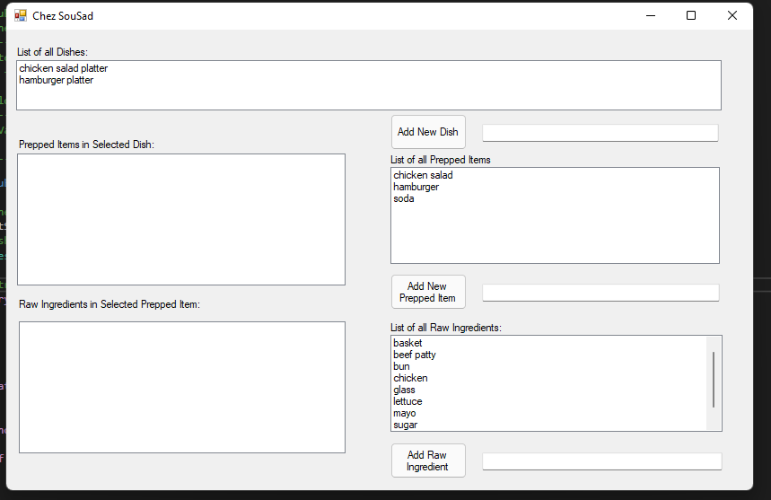

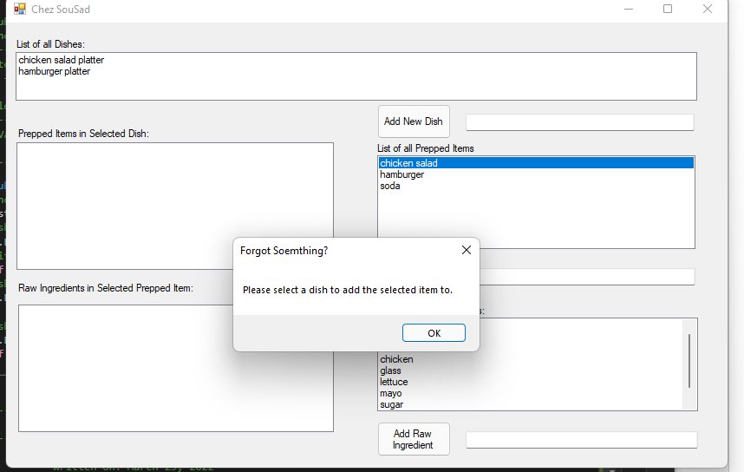

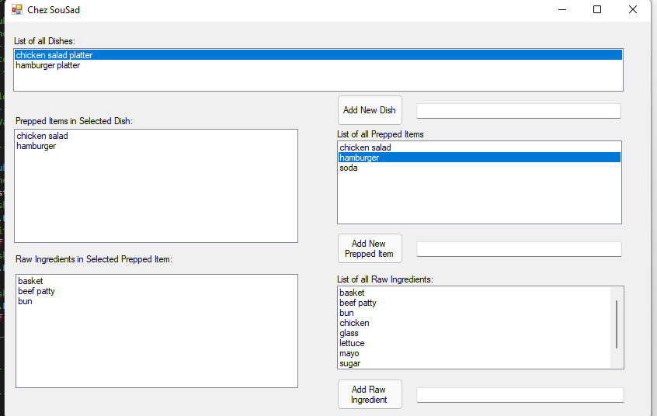

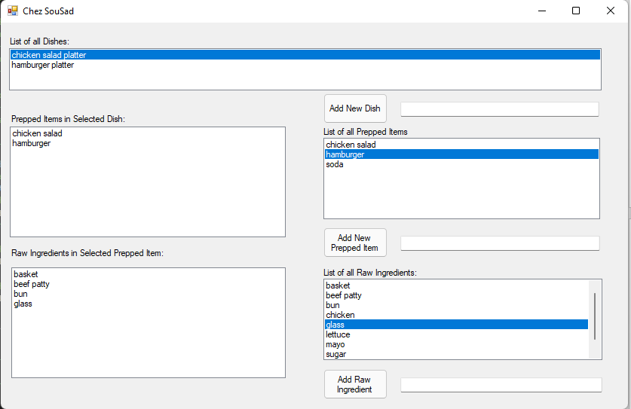

*wont let me take a pic of the none cursor but its there